**KDC homework 4**

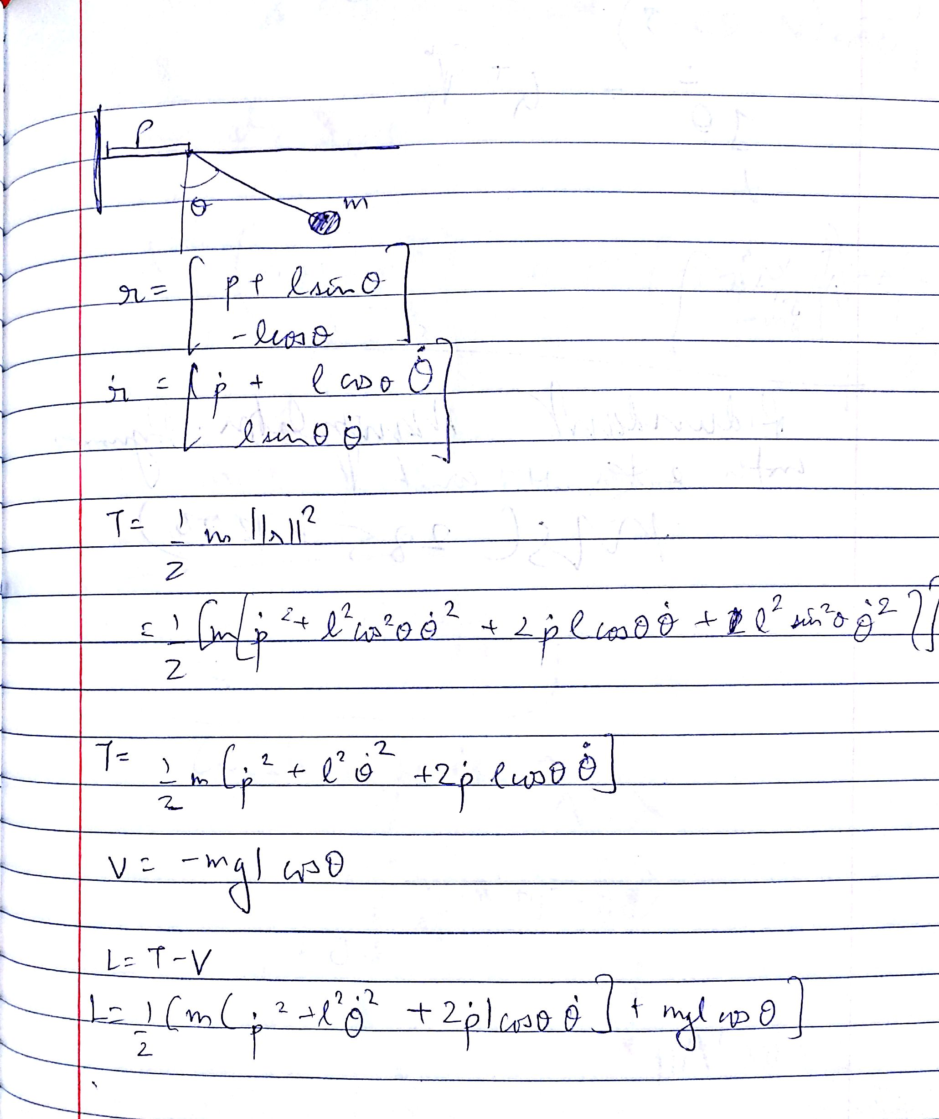

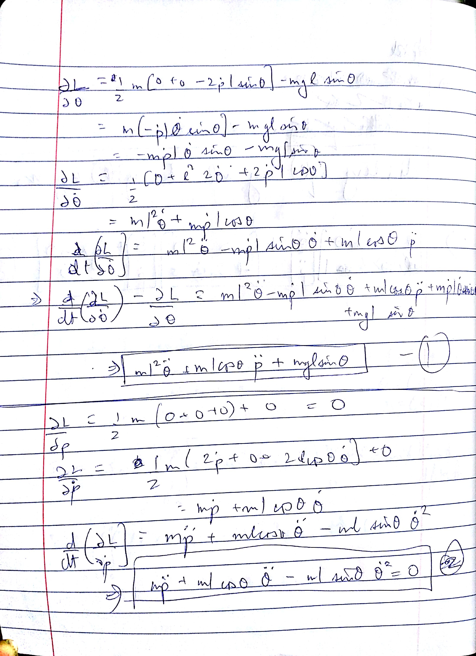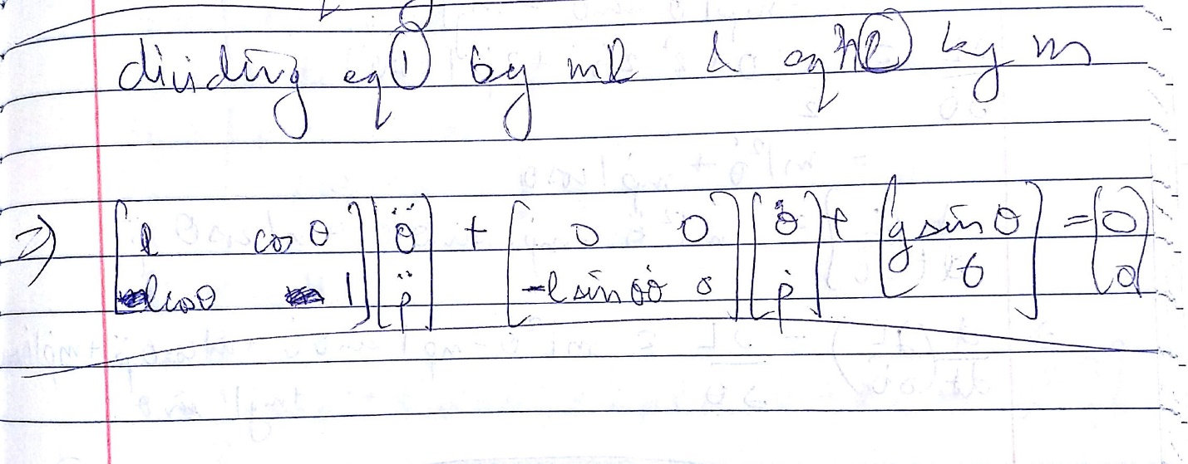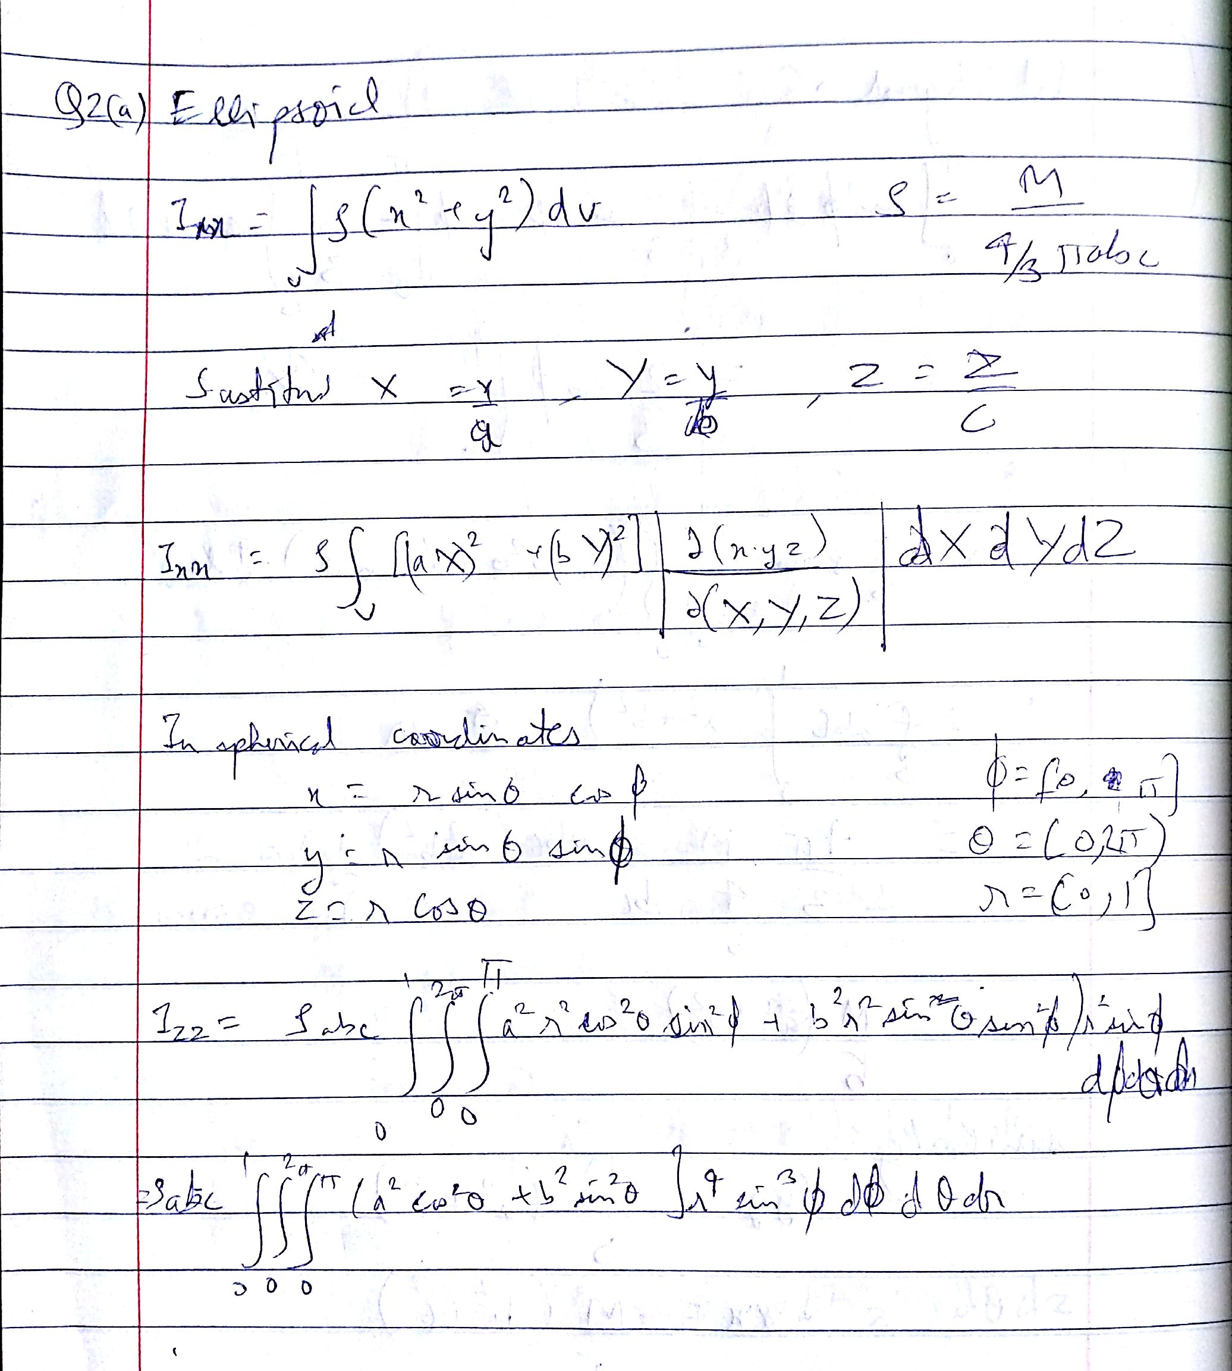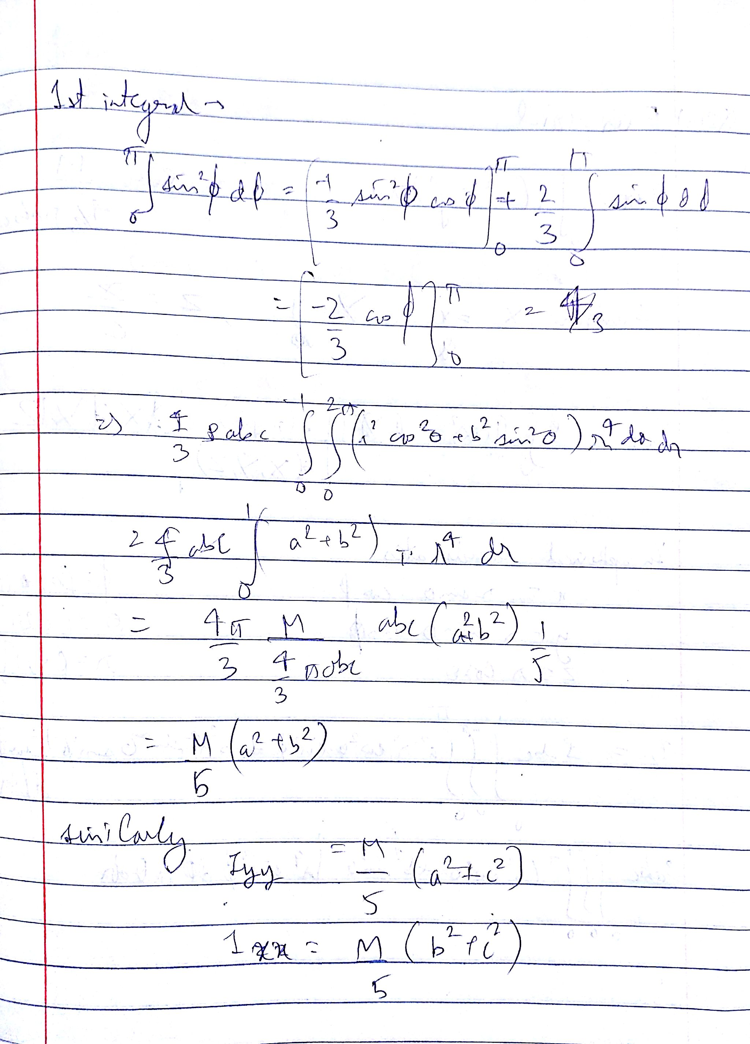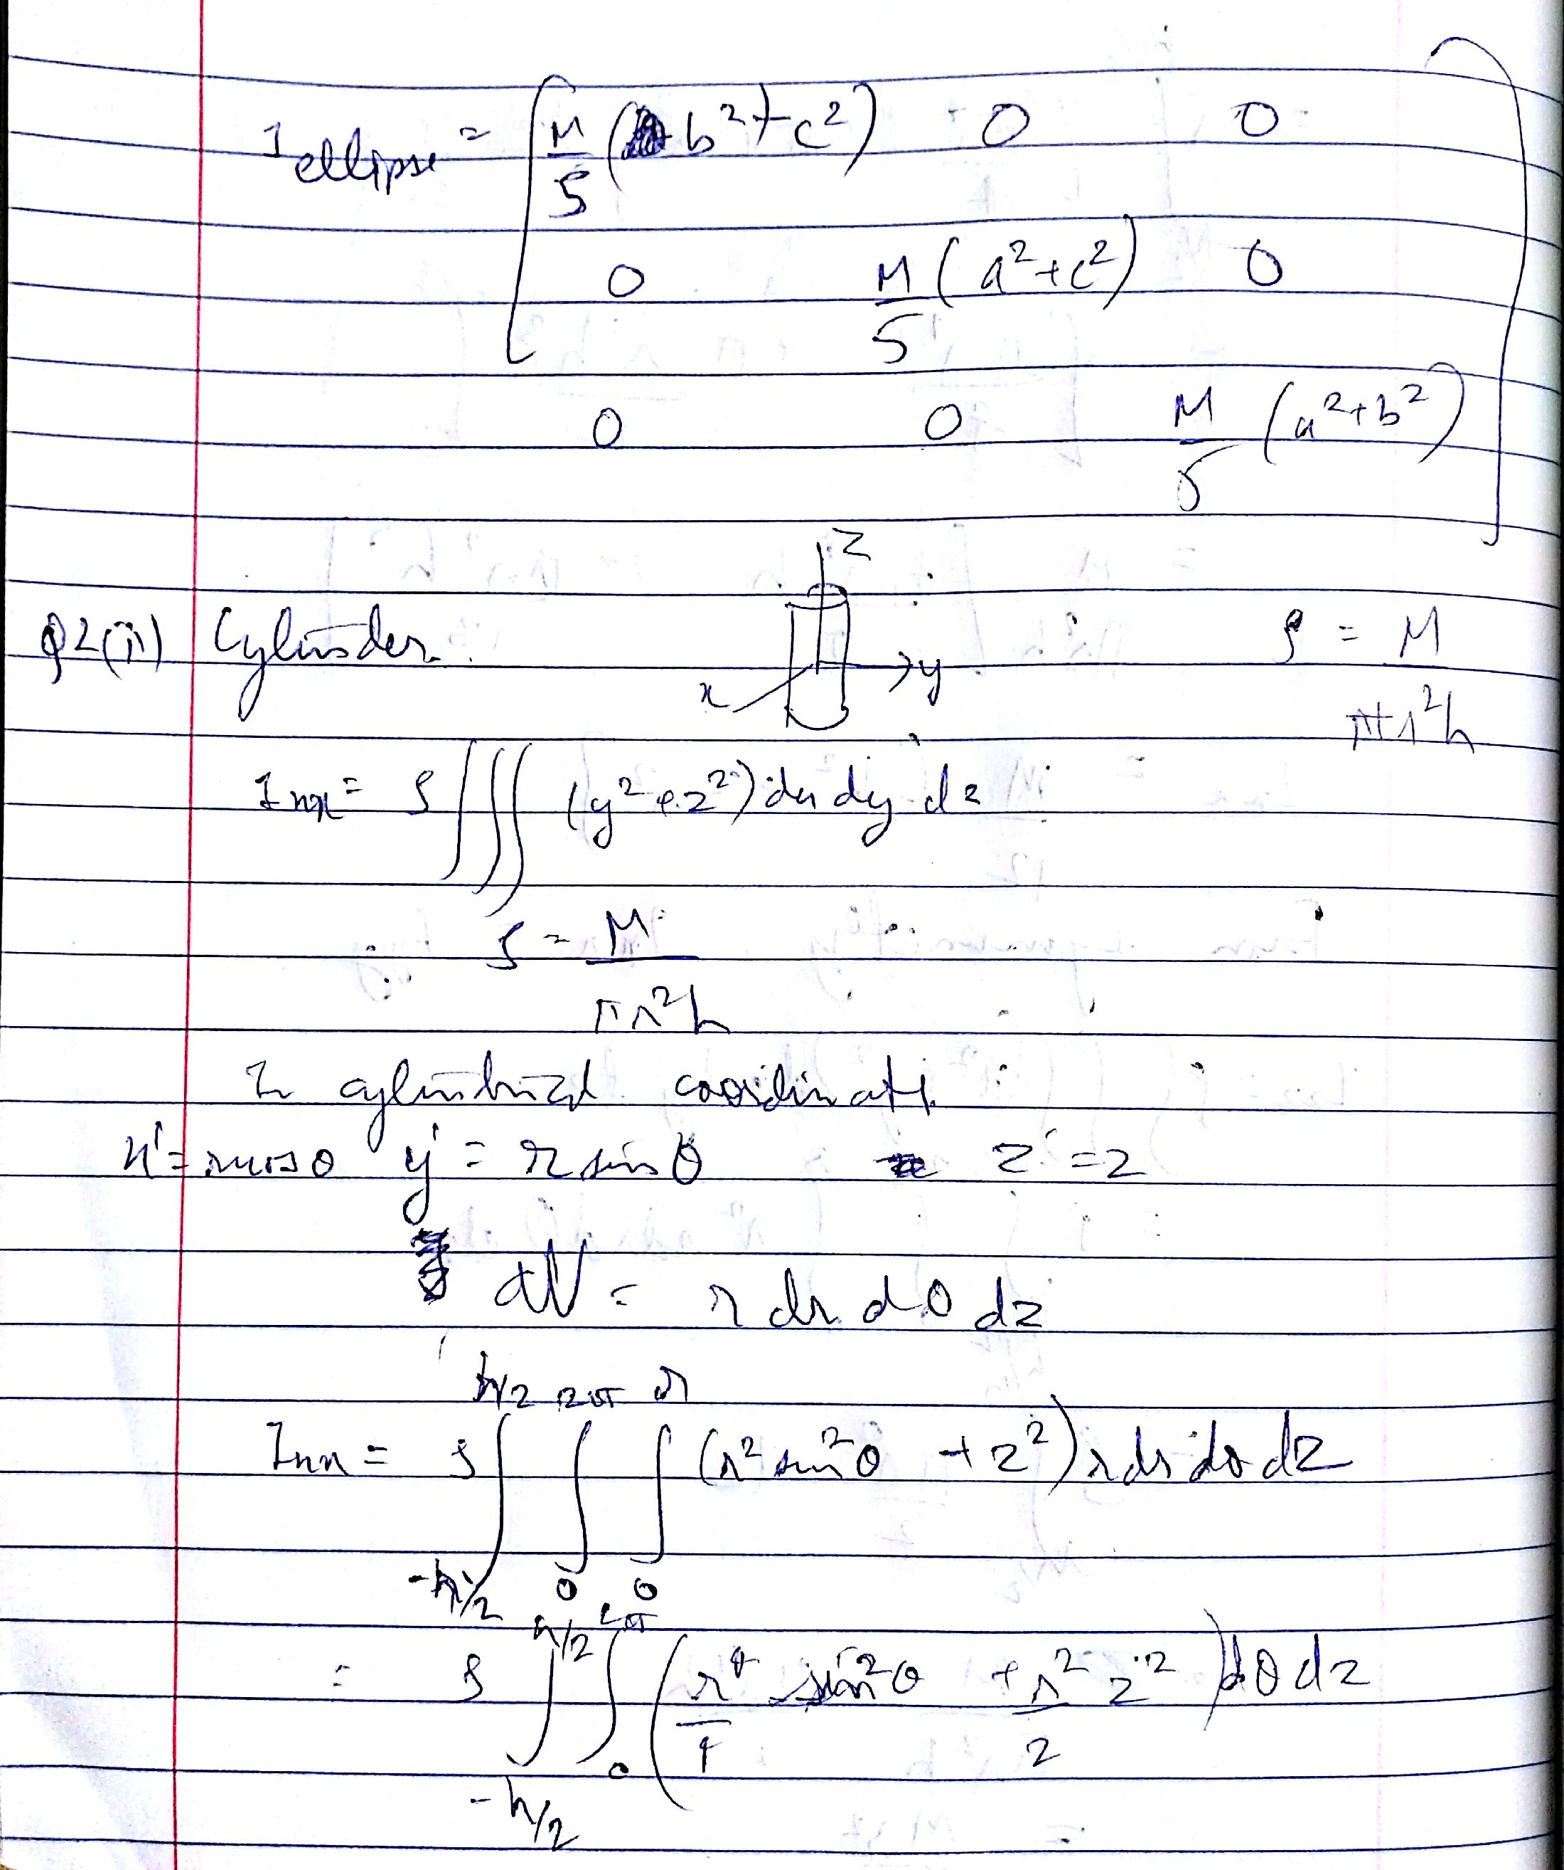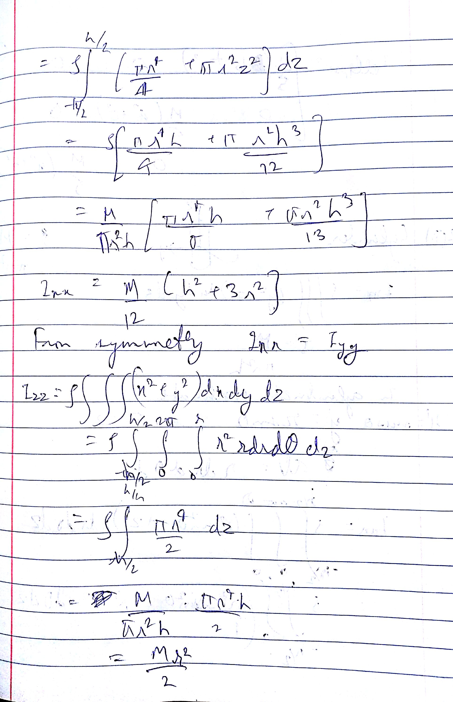

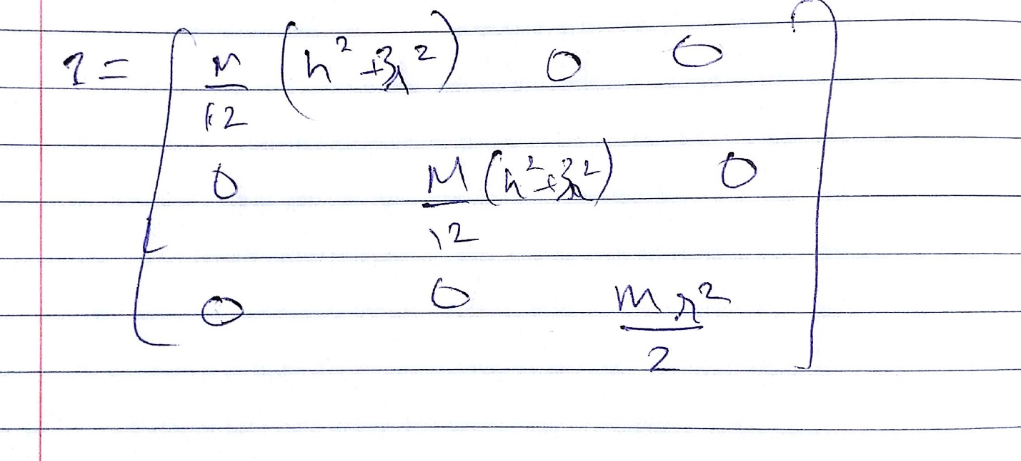

Q3 –

3.1

The velocity of the COM is

3.2 The inertia Tensor of the asteroid is –

3.3 The Inertia tensor of the principal axes is (found from the eigen values of the previous matrix–

Since all 3 principal moments of inertia are different, it is probably an ellipse.

3.4 The beacon landed on the following coordinates, wrt COM (or body)–

The distance from the COM is the norm of the vector = 0.3 units

3.5 The average angular momentum of the asteroid is

4. <project proposal sent separately via email>